The image behind LOGIN/REGISTER and the OTP is cropped. Can we position it so it is not cropped?

Also, when I enter the OTP screen, is it possible for the email to be automatically filled in so that I only need to enter the code?

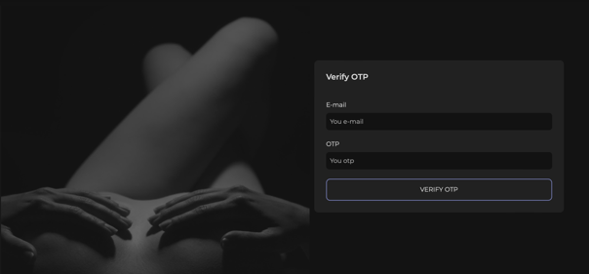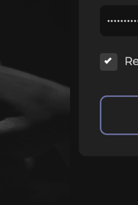  
  
Pictures cutting.  
  
You need to adjust the icons to ensure they are the correct size and properly aligned, without being cut off or misplaced. Additionally, make sure to arrange them in the correct order.

**Correct Order:**Your Profile  
Home  
Latest News  
Messages  
Members  
Friends  
Gallery  
Speed Dating  
Groups  
Events  
Forum

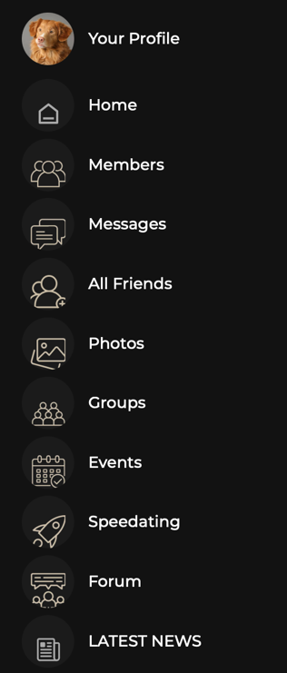

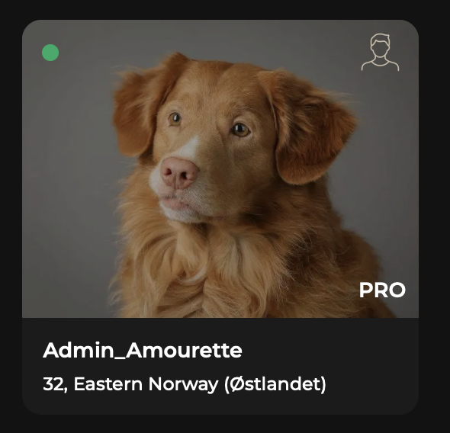  
  
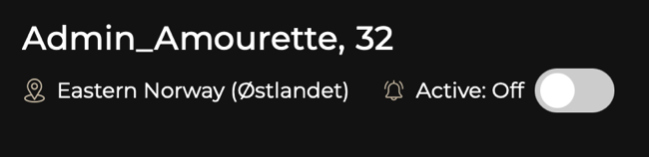  
  
I see you’ve activated ‘Members’ with discretion, icons, and login. However, Oslo must be displayed explicitly, not just Østlandet.  
  
The green online indicator works, but pressing ‘Active Off’ still shows me as online. Users should be marked green when active and automatically set to offline when they leave. If they press ‘Active Off,’ they should remain on the site without the green indicator.  
  
Also, please display the selected orientation (“heterocouple” or “female”) alongside the gender icons above the image.”  
  
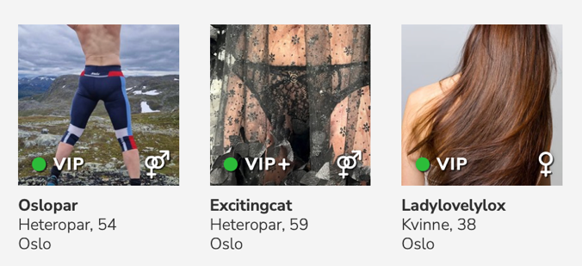  
  
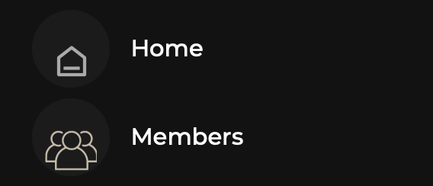  
The ‘’HOME’’ icon is more white and not the same color as the other icons.   
  
  
  
  
  
  
  
  
  
  
  
  
  
  
  
  
**Preferences vs Sexual Oriental:**  
Intelligent matching logic that effectively filters profiles to ensure both parties have mutual interests.

**1. Sexual Orientation:**• This indicates who you are attracted to (e.g., “I am a man looking for men”).  
  
**2. Preferences:**• This defines what the other person is looking for (e.g., “this profile is looking for a man”).

**How this simplifies the search:**• When you set your sexual orientation (e.g., “I am looking for a man”), the system will show you profiles of men.  
• When you check preferences (e.g., “I only want to be shown to those searching for men”), you will only be visible to profiles actively looking for someone like you.  
• This creates a double-filtering system, ensuring that you only see profiles that match your preferences and have also indicated that they are looking for someone like you.

**Benefits:  
More accurate matches** – Avoid seeing profiles that are not interested in your gender.  
**Efficient filtering** – Save time by only seeing relevant profiles.  
**Simplified experience** – The system ensures that both parties have mutual interest.

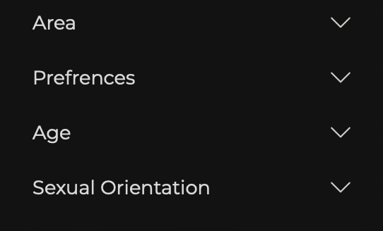 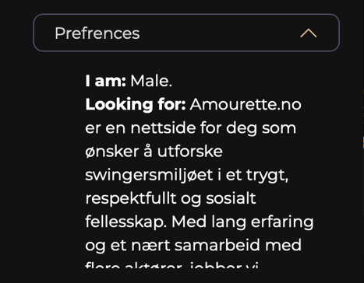

Now:  
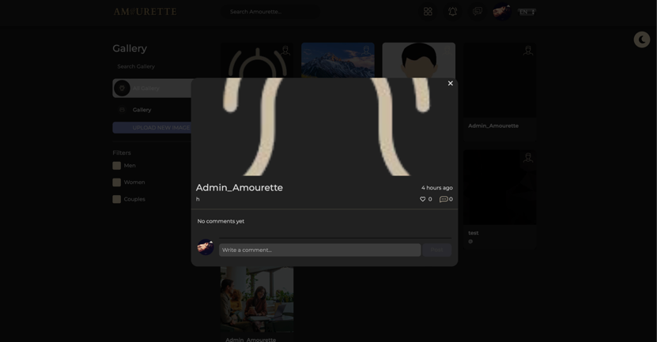  
More like this:  
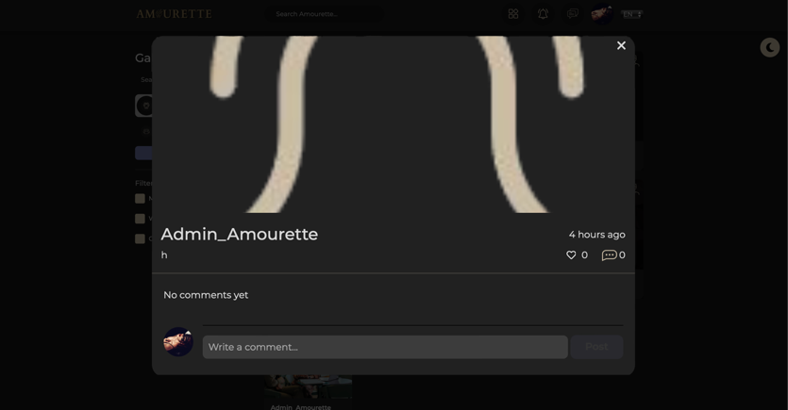  
  
The image preview must be significantly larger when clicked, and we need to ensure that both the pre-click and post-click display prevent the image from being cropped. Additionally, users should be able to click on the uploader’s name directly from the image preview to access their profile.

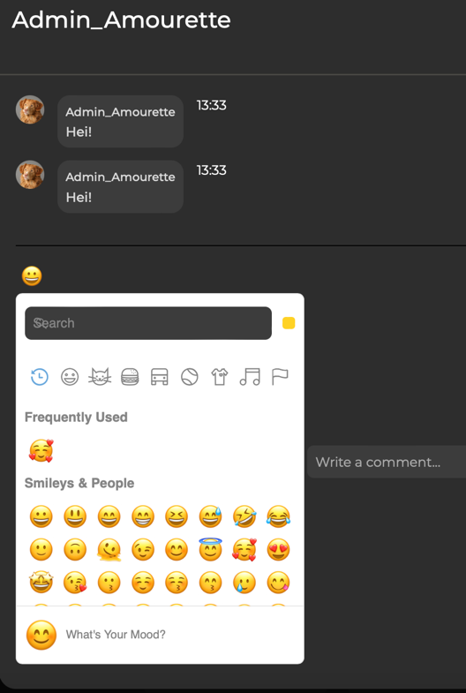  
The comment function on images doesn’t work when I try to select an emoji.  
When I type ‘Hei’ and then press the emoji button to choose an emoji, the message ‘Hey’ is sent before I can add the emoji.

The images are currently being cropped, and we need to find a solution for this.  
  
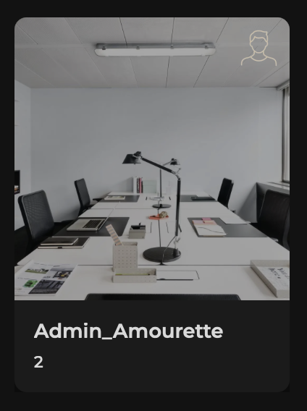 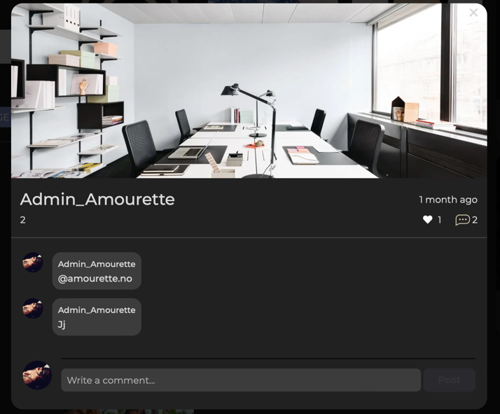  
  
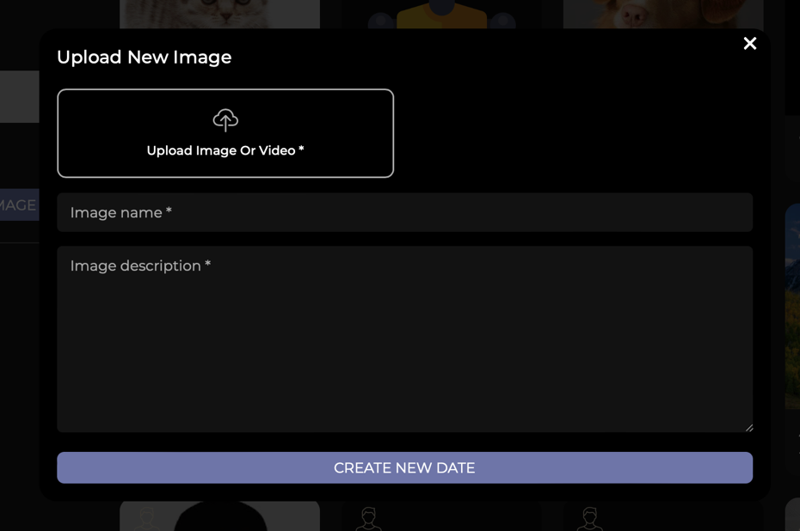  
When I upload new picture it’s says ‘’CREATE NEW DATE’’??  
  
  
  
  
  
  
  
  
  
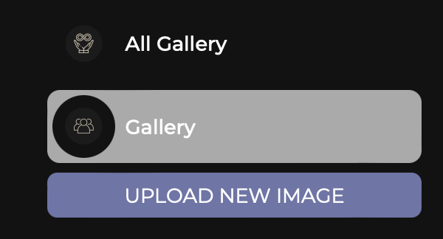-  
Gallery and All Gallery?  
it shoud be this like the FIGMA FILE.  
  
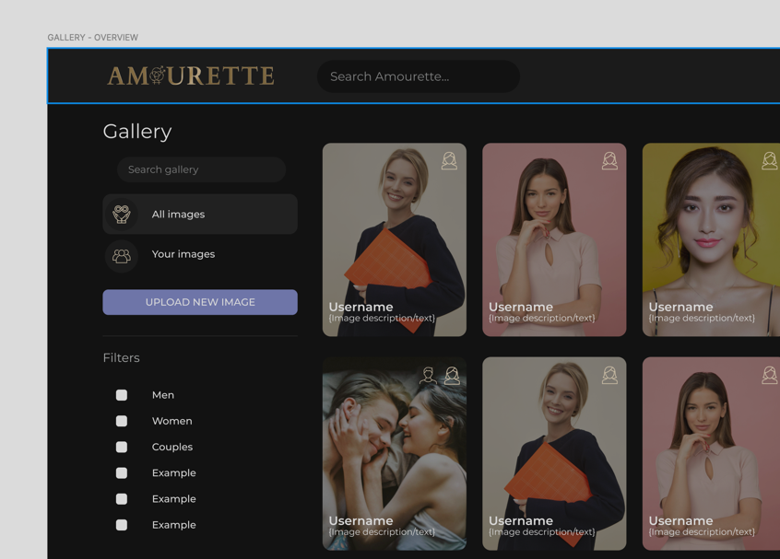

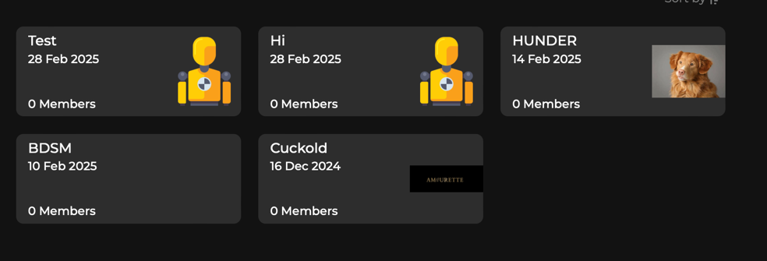  
The **image size** must **not be cropped** in **groups**, same as under but not cropped and auto fitted to the side.   
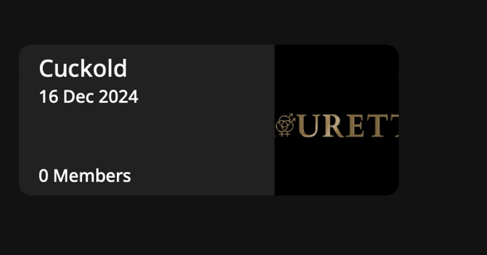  
  
  
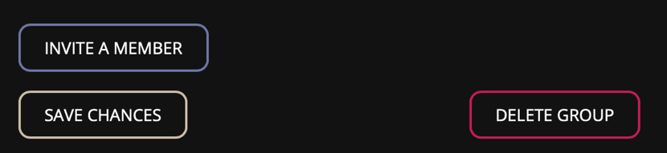  
The **buttons** in the **groups** must be arranged in **sequence**, placed **next to each other**.  
  
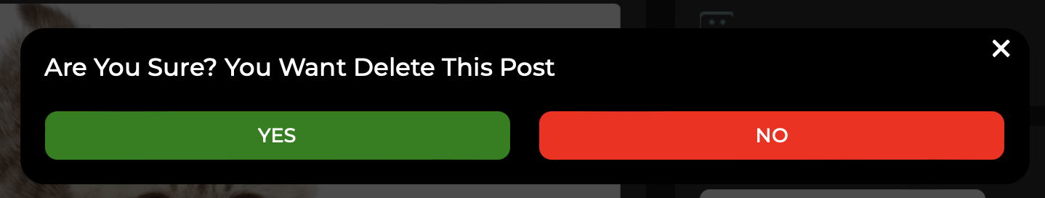  
Change button colors to the amourette colors f.eks the purple color and gold.  
  
  
  
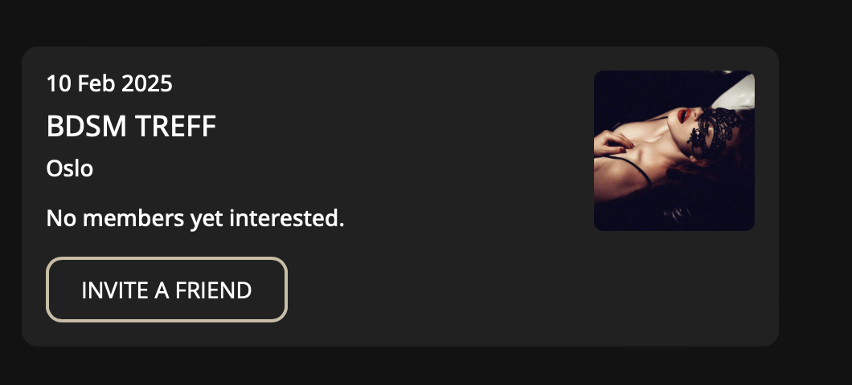  
• When I create an **event**, the **image appears very small**—this needs to be **adjusted**.  
  
  
  
  
  
Speed date adjusments: this looks like and EVENT now, that is totally wrong. You don’t need to press  
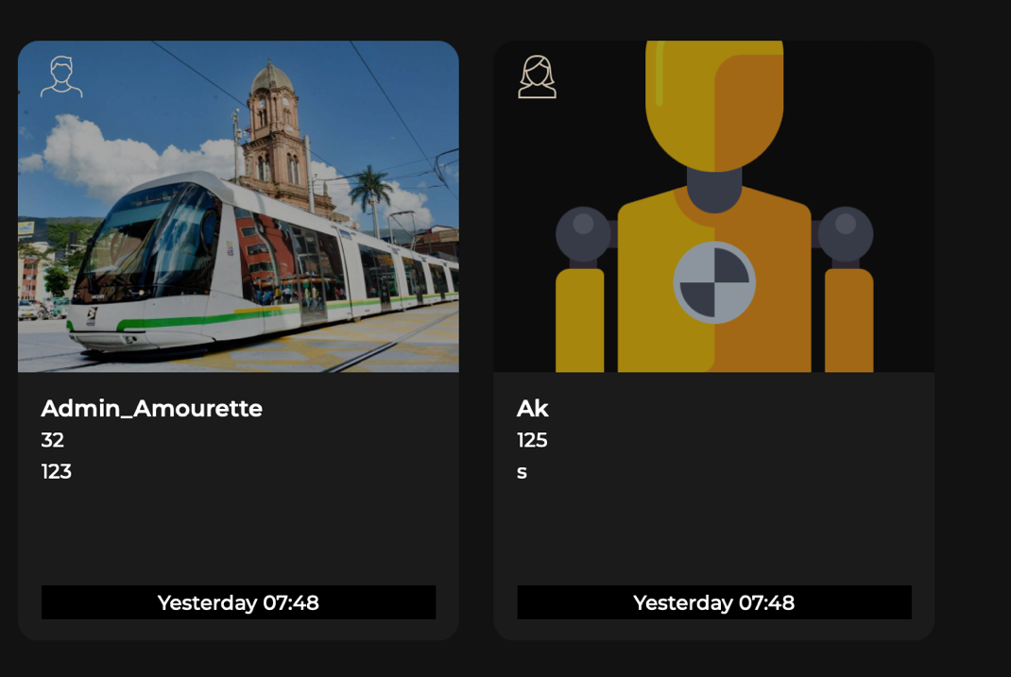  
Now  
  
Better:  
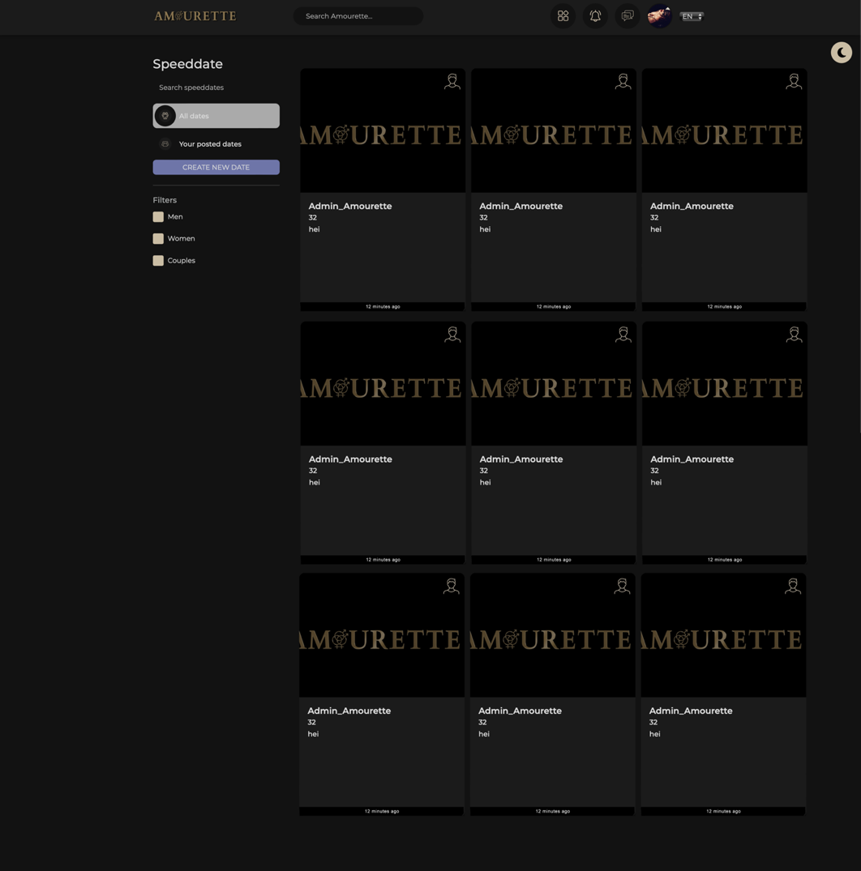  
  
  
  
  
  
  
Inspo:  
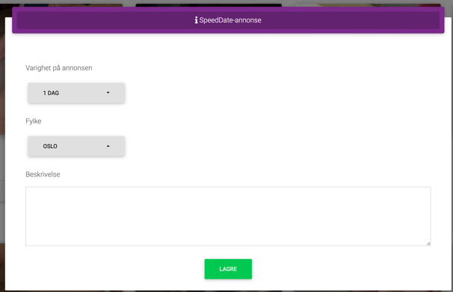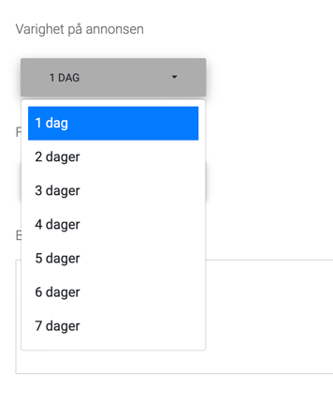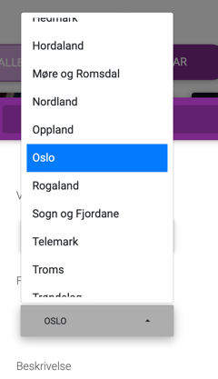  
 **Speed Dating Info:**

The filter must include the following options: **All, Men, Women, and Couples**. Additionally, we need to include **location filters** for counties, just like when searching for members (i.e., **PLACES**). This should be placed under the **Gender filter**.

Speed dating posts should be **larger and more prominent**, and we need to add a **timestamp** indicating when the post was published. For example: *“12 minutes ago”* or *“two hours ago”*, counting from the moment the post is submitted until it is displayed.

When creating a speed dating event, users must be able to select how long the post should be visible: **1, 2, 3, 4, 5, 6, or 7 days**. They should also be able to **choose the county** and **write their own advertisement**.

Additionally, users should have the option to **keep the “Use Profile Picture” function** when creating their speed dating post as it is now, this is good.

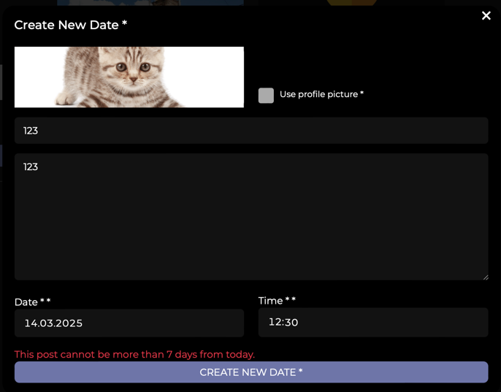  
  
  
  
  
  
  
  
  
  
  
  
  
  
  
**Forum Page and Suggestions for Improvement**  
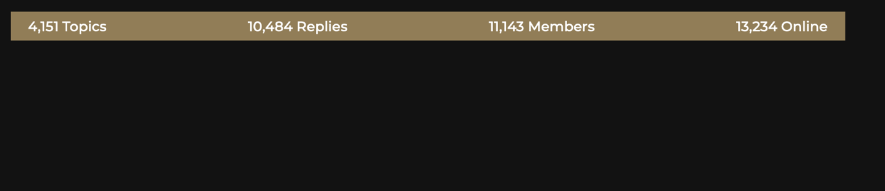 **This is not a part of the design – this is going to be a real-time counter counts all the topics posted, all the replies, all the members on the site and how many members are online.**  
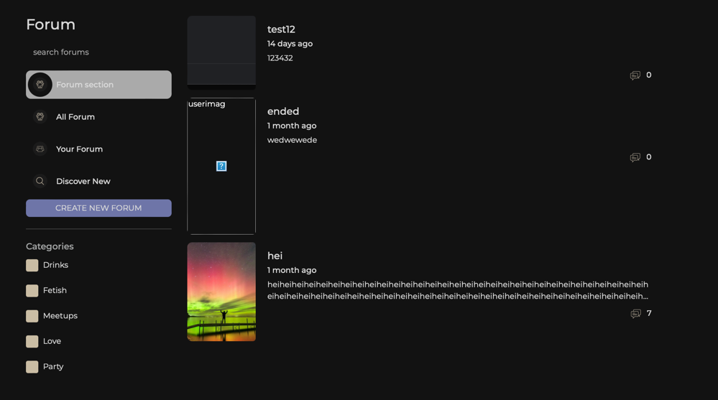  
  
The forum is difficult to navigate and use. It’s very unclear how things work here, and the overall structure feels messy and unorganized, especially when it comes to tags and the way the forum operates. I would prefer if they used the same layout as in Figma but adjusted it for real-world use. I’ve also attached an image of the homepage, which I believe simplifies the design and aligns better with Amourette’s aesthetic.  
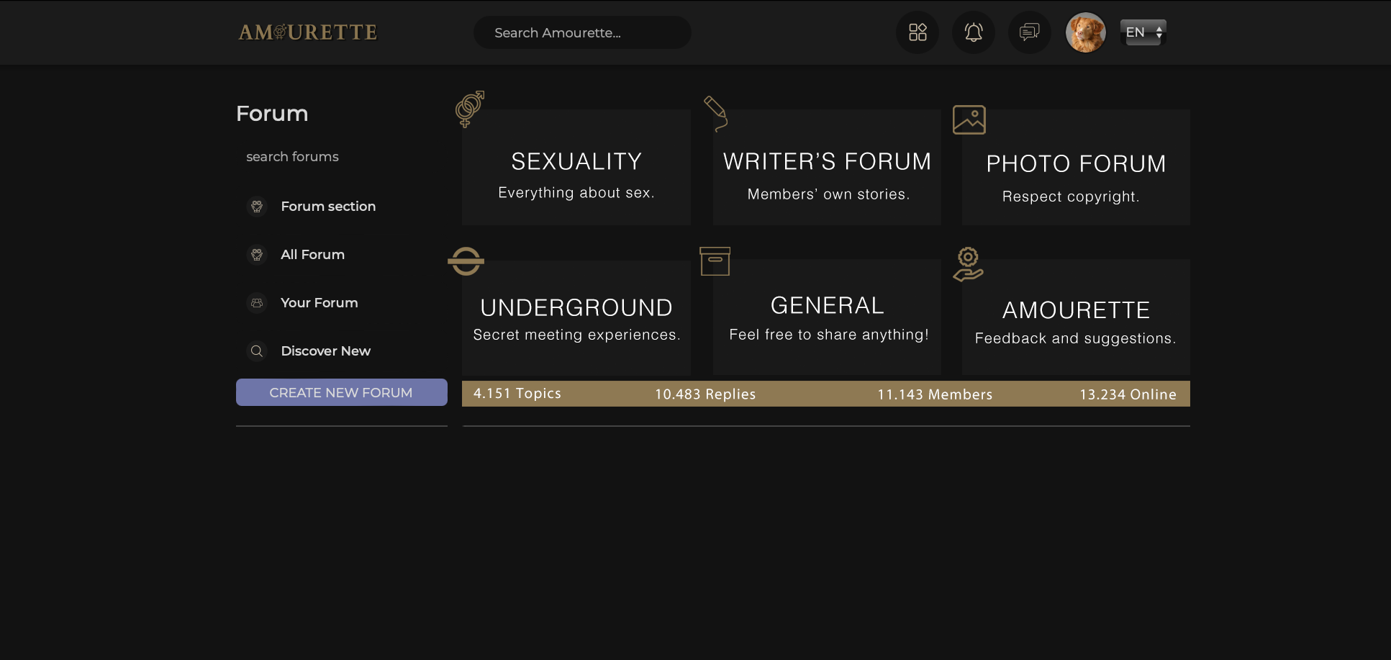

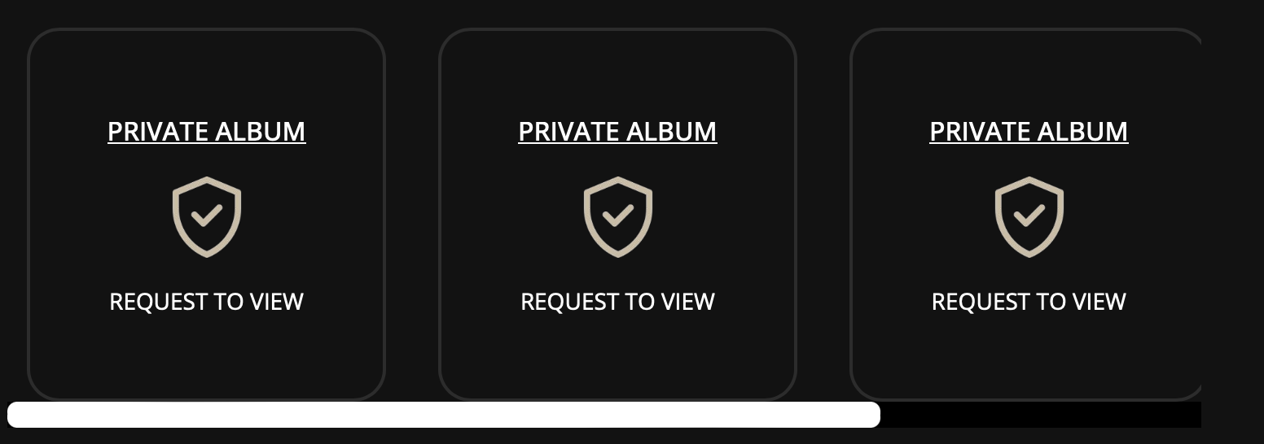  
Each user can have up to 6 albums.

You can decide who can see each album – for example, Album 1 and 2 can be public when when you press folder 1 a new tab opens where all the pictures are uploaded with no limit. There also need to be a way to delete pictures that are uploaded to each album. How do I delete pictures? How do I upload pictures to FOLDER?  
  
And while Album 3 is private and only visible to those you grant access to, and so on. The user can choose:

Also, the **“white line”** used for **dragging sideways** should be made **a little bit bigger, just a little.**

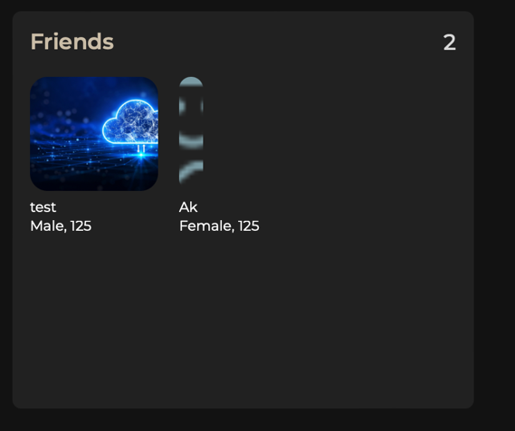  
Friend of ‘’Admin_Amourette’’ as you can see the profile picture for ‘’AK’’ is cropped.   
  
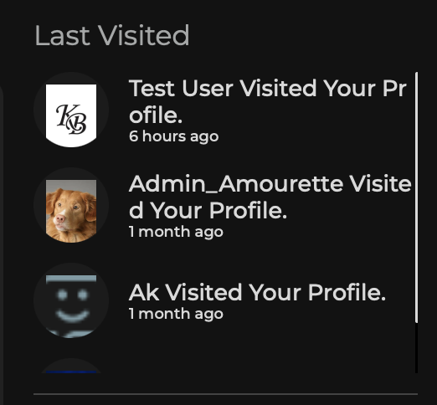  
No need to have ‘’Visited your Profile’’ just have the **username.** Since it’s says over Last visited.  
  
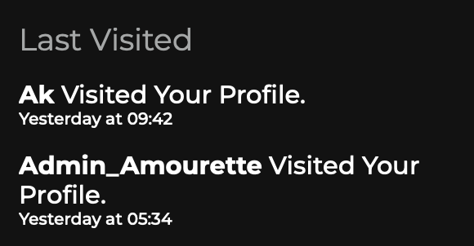  
Also what happened to the picture of the user? It must be with picture.  
  
  
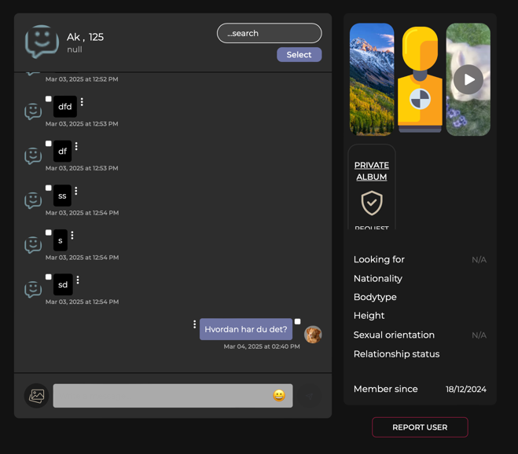  
  
  
You should ONLY be able to delete your own messages, not the other person’s messages.  
The images that appear on the right side should be the images or files that have been **shared in the messages**, **not from the person’s profile**.  
  
Additionally, I must be able to **click on the profile picture** of the person I’m chatting with to access their profile.  
  
Pressing the **“ENTER” key** on the keyboard must send the message.  
When I press “Send,” the page **should not jump** or move.

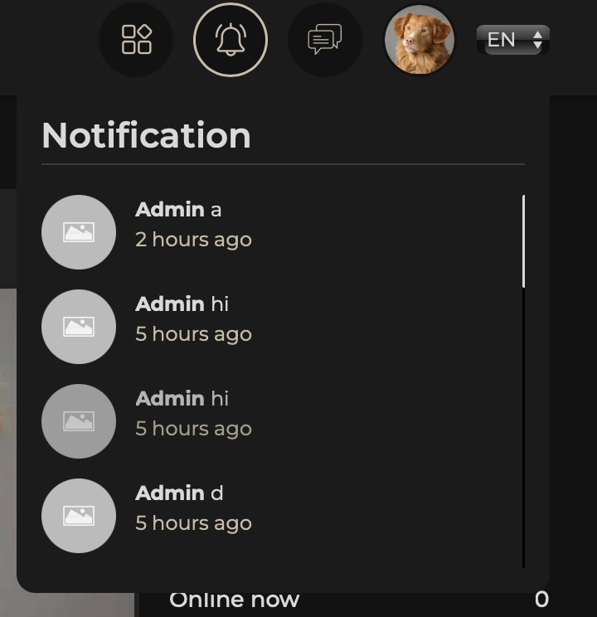  
**What are the notifications currently linked to?**

It must be, you receive notifications when someone comments on your photos, likes your photos, or tags you with “@” in images, posts, forums, or events. Additionally, you get notifications for your own created events or forum posts whenever someone joins, comments, or likes them or you have joined a group, forum og event and someone writes or comments anything.

**For messages**, you receive a notification displaying the number of unread messages with a numeric icon, indicating whether you have 2, 5, or even 100 unread messages.

For reference: 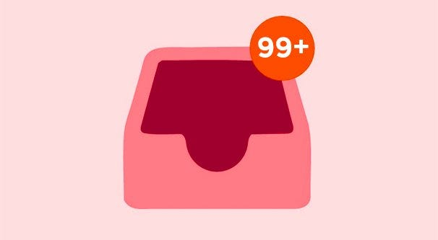  
  
  
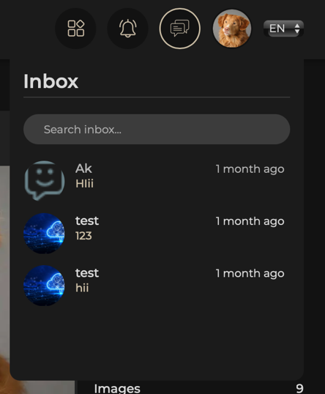  
Also im not able to press into messages. Nothing happens when I press on an message.  
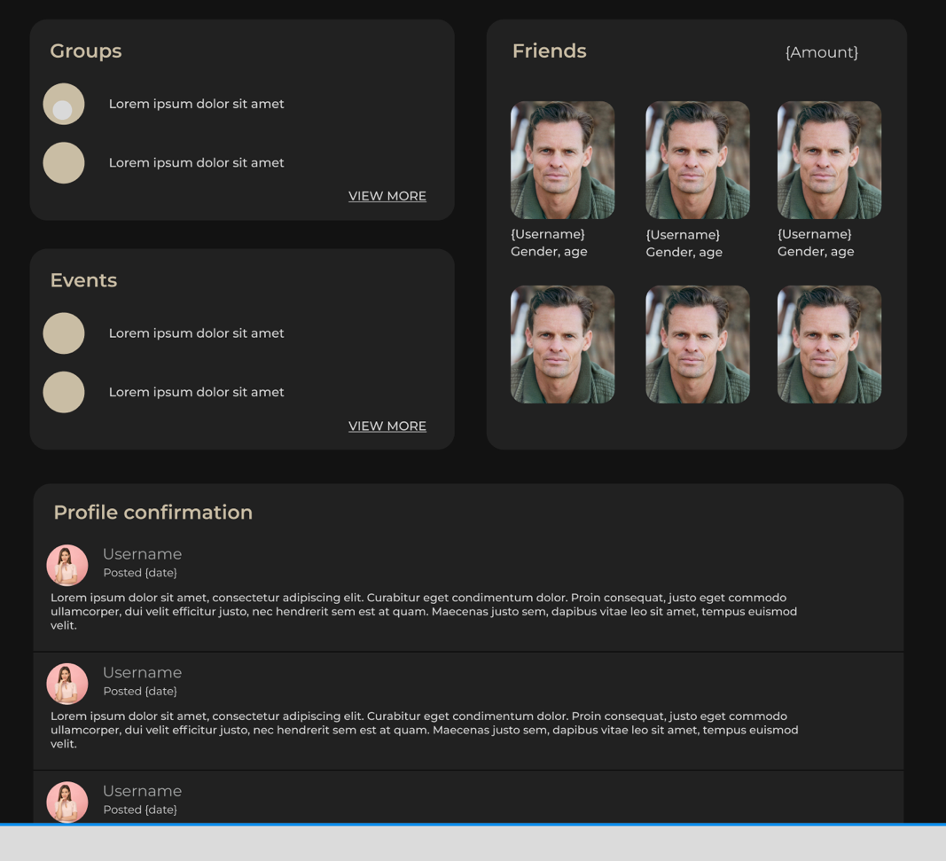  
  
A “writing wall,” similar to a Facebook feed, has not been implemented on user profiles. This feature should be available on all profiles, allowing other members to leave comments on another user’s profile. For example, they should be able to write a review or share an experience, such as: *“I met this couple, and they are serious.”*  
  
Each comment must include:  
• **Written by:** *Username*• **Date and time stamp:** Automatically generated for both date and time  
This should function exactly as shown in the example image but in Amourette style.  
  
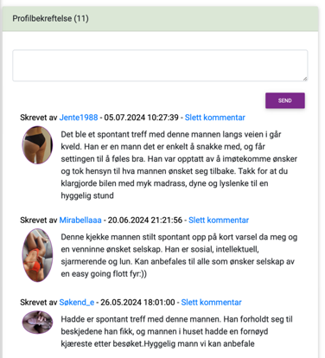  
  
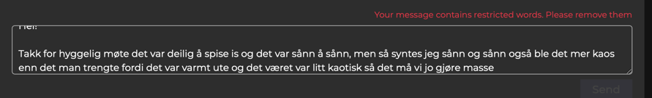  
Not working. What is this red message? And when I press to post it it does not post.  
  
  
  
  
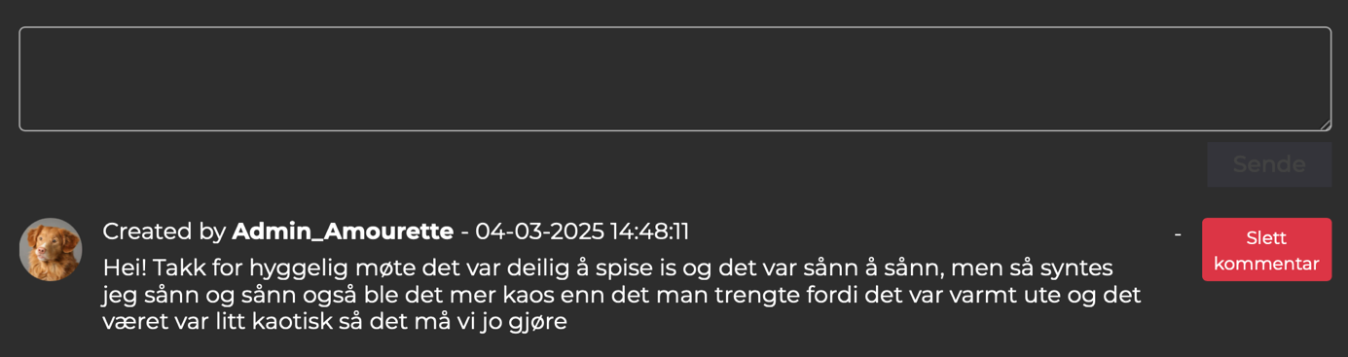

It was posted on MY profile instead? When I tried to post it on ‘’TEST AM’’ profile.  
  
  
  
  
  
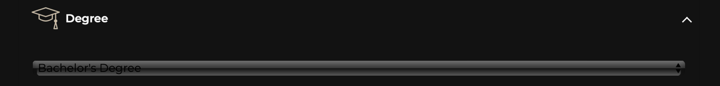  
Hard to read the text here?

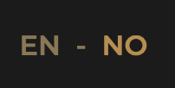  
Keep the gold color to 8c7651  
And the EN to light grey when not pressed.  
  
  
  
  
  
  
  
  
  
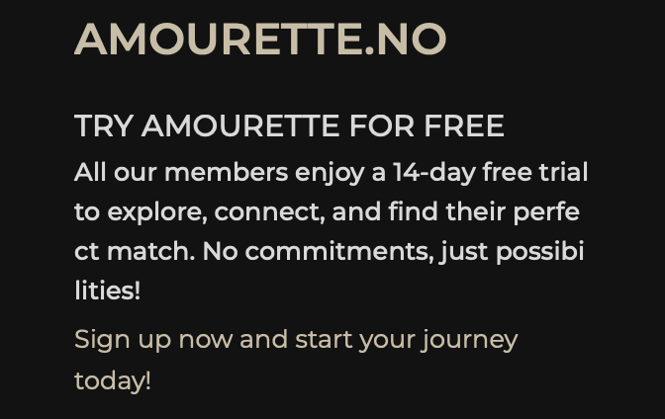  
This is the text before they login/sign up. It’s perfect.  
  
When the are signed up, make it automatic change to this:  
  
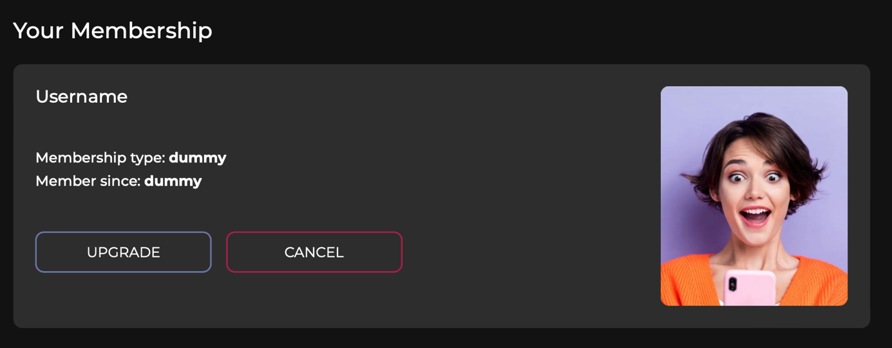  
  
  
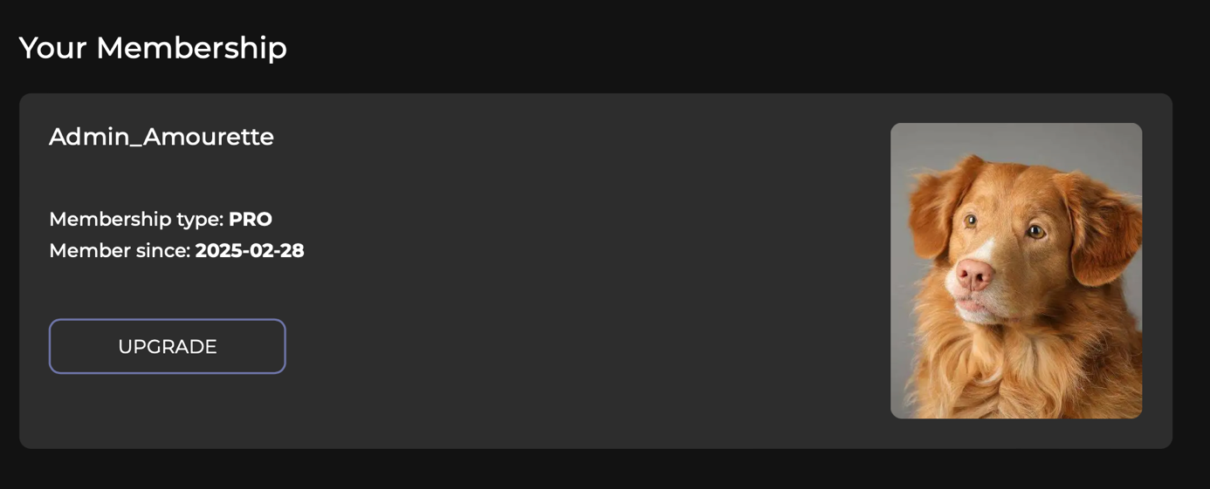  
  
In the FOOTER: Contact us and MEMBERSHIP are showing this? Witch is the same?  
  
  
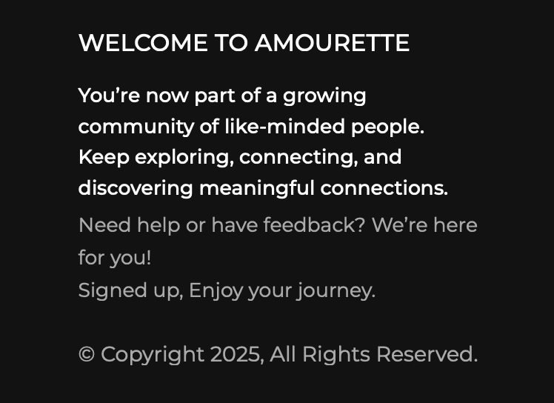  
Text is cutting ‘’for you’’ big space after. Make sure its clean and elegant looking.   
  
  
  
  
  
  
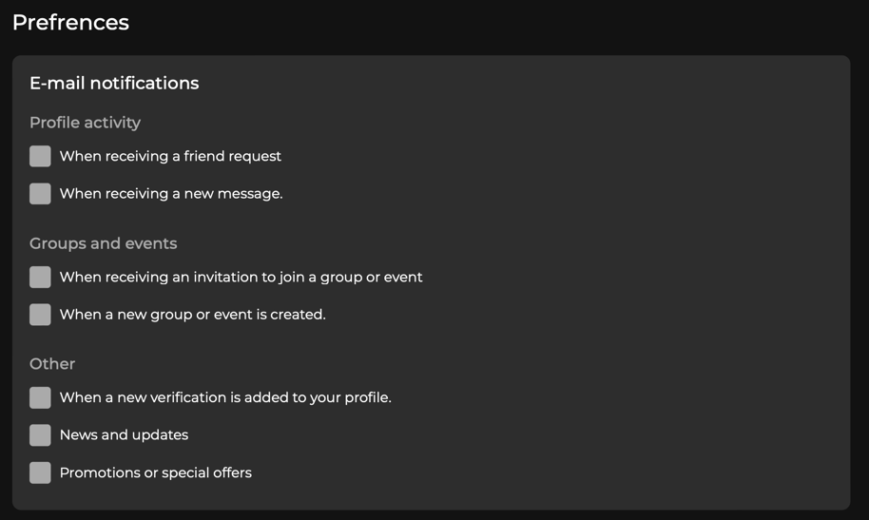  
Add fuction to stop ALL notification on e-mail but reseve them only on the website. Like the last days with all the updates I want them on the site but I don’t want them on my email.   
  
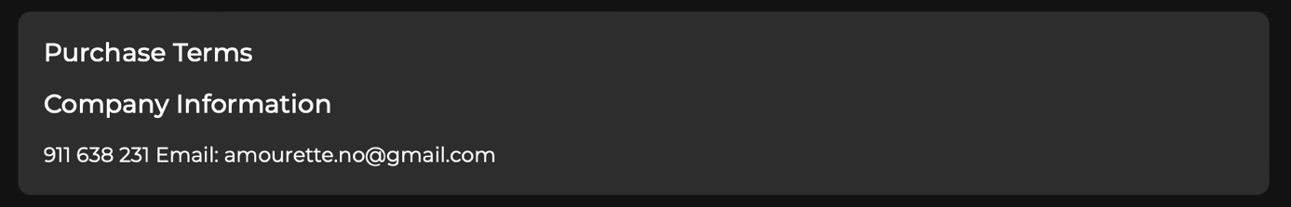  
Remove number. Keep just email with big A.

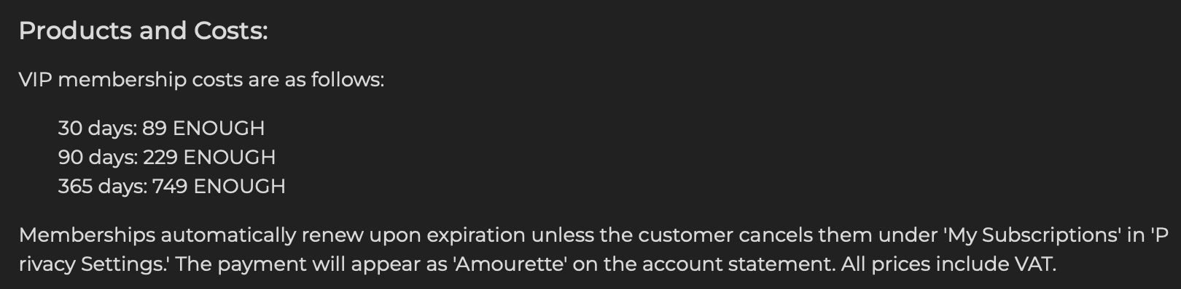  
Change prices to the right prices and make sure the pricing comes in same line as ‘’VIP’’   
  
• **30 dager: 89 NOK**  
• **90 dager: 229 NOK**  
• **365 dager: 649 NOK**  
  
  
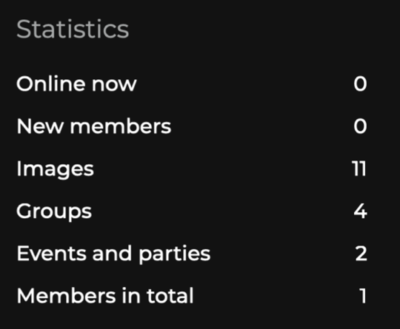  
There are made groups and events and users – why do they not show up on this bar on front page? This needs to be on automatic scanning the site.   
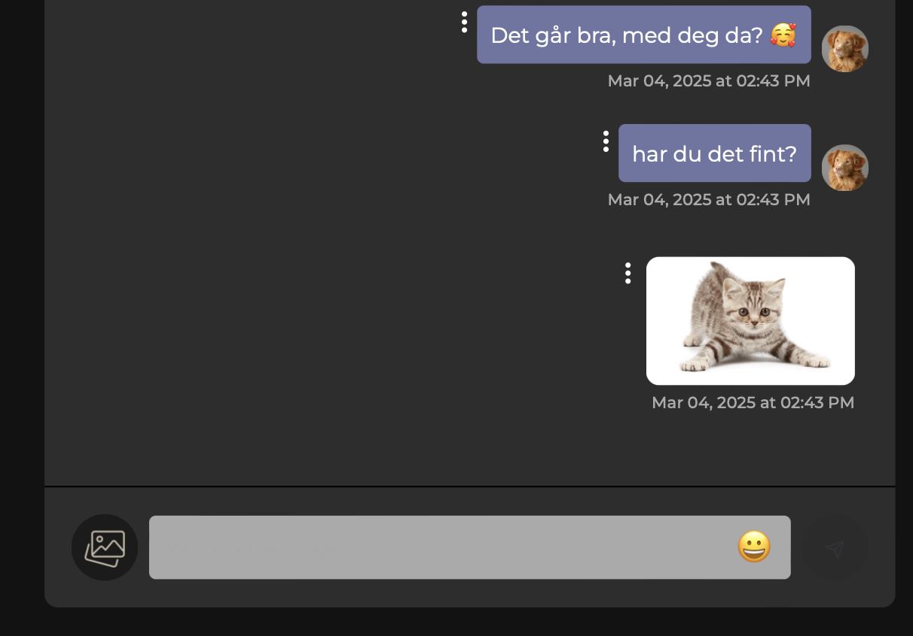  
When I open picture In messages it’s working. But I want to press ESC to close it also or cancel the big size etc.   
  
  
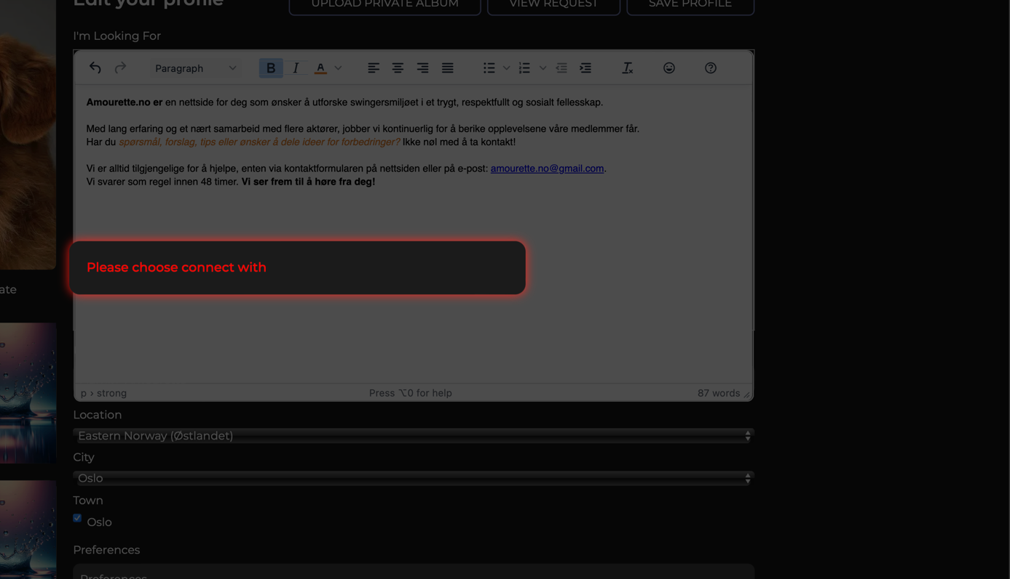  
When I try the new text edit and try to save this shows up.  
  
  
  
  
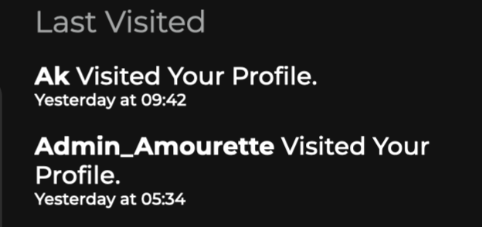  
Make date and time a big bigger. Show profile picture on the user also how have I ‘’visited’’ my own profile?

Edit Event info like this when you se members:  
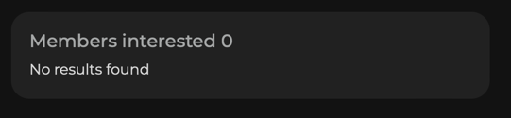  
  
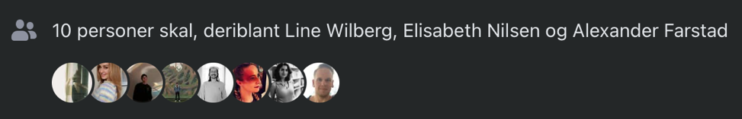  
  
  
 GUESTS:  
Going – Maybe – Invited – Not going  
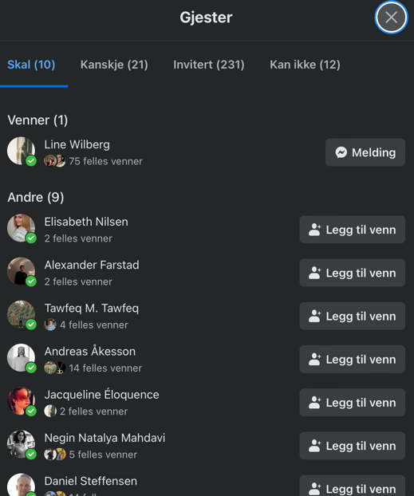  
Same as Facebook.  
  
  
  
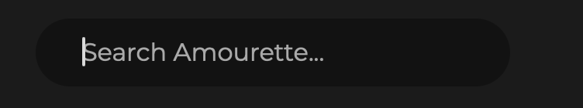  
Search don’t work accurate. It should be for profiles, events, groups, members and everything. To find things easier.  
  
It looks bad when I write also. Please fix this also.   
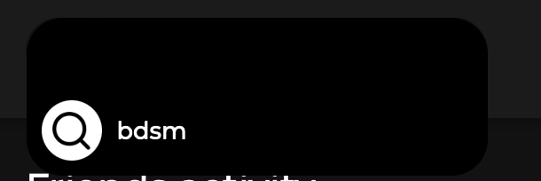  
  
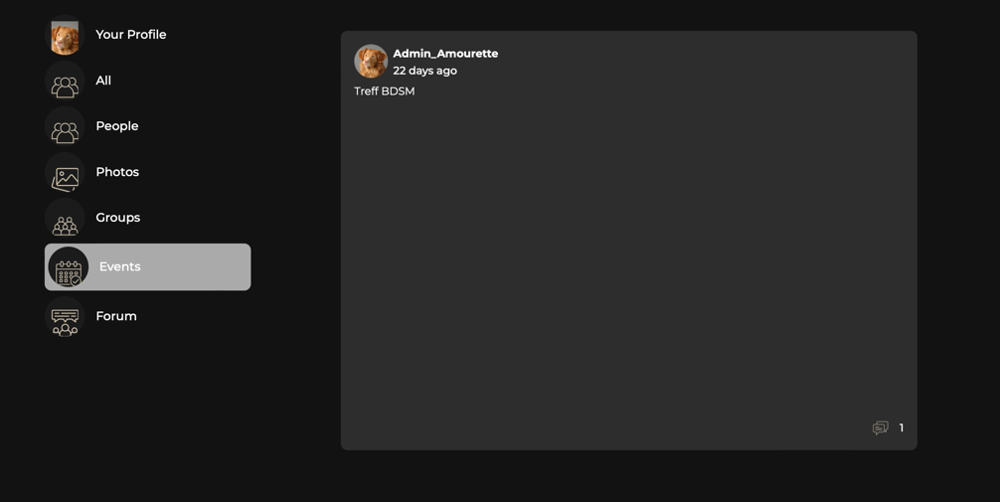  
**The event(s) and rest are not displaying properly. Additionally, the side icons and the profile picture look terrible. The profile picture is not positioned correctly, and the icons are displayed in their default size and appearance.**  
  
  
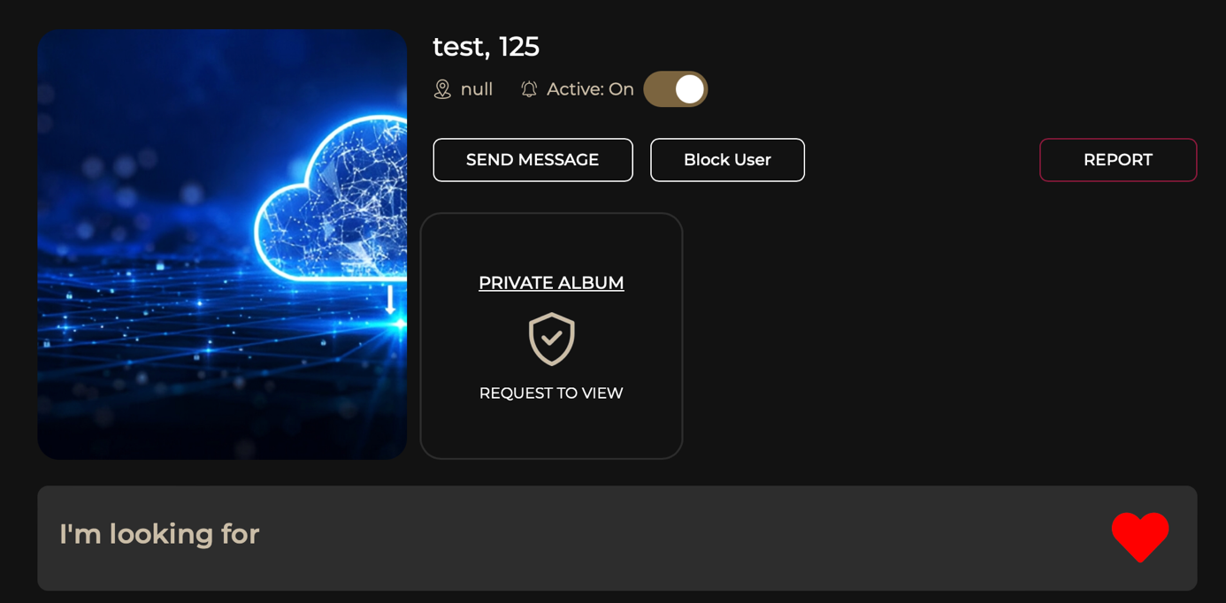  
  
  
  
Add the “Favorites” section at the top after or before “Active,” whats looks the best. And use the same gold color code from the site, Include a heart icon for adding favorites.  
**Note:** You can only add an existing contact or a **friend** as a favorite.

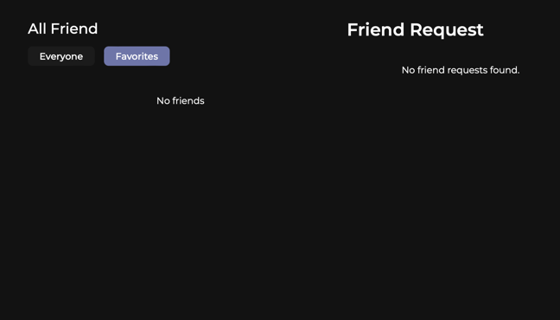  
All your friends show up here and also FAVORITES after they have been added.   
Favorites should be marked without notifying the other user, making it easier to track and follow preferred profiles.   
  
  
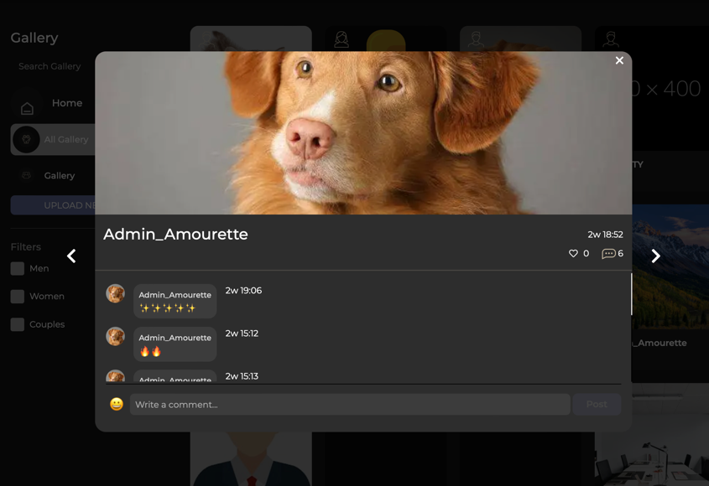  
Ensure that users can navigate through images using the **left** and **right** arrow keys on the keyboard. Additionally, pressing the **ESC** key should close the image viewer.

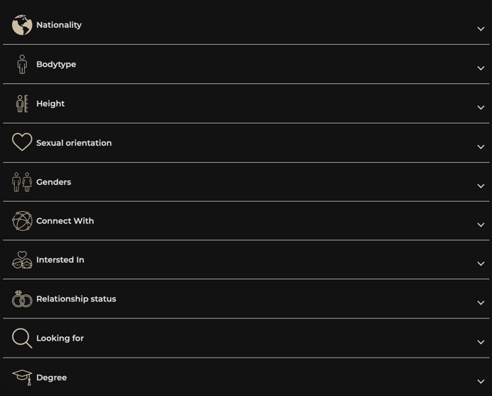  
Profiles should not be saved until all required fields are completed. And making it easy for users to see where they have forgot to fill in information.   
  
  
  
  
  
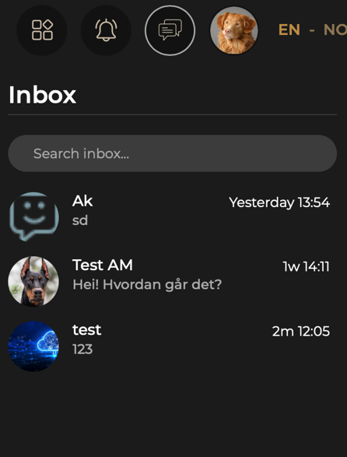  
Include show all button to open all messages.

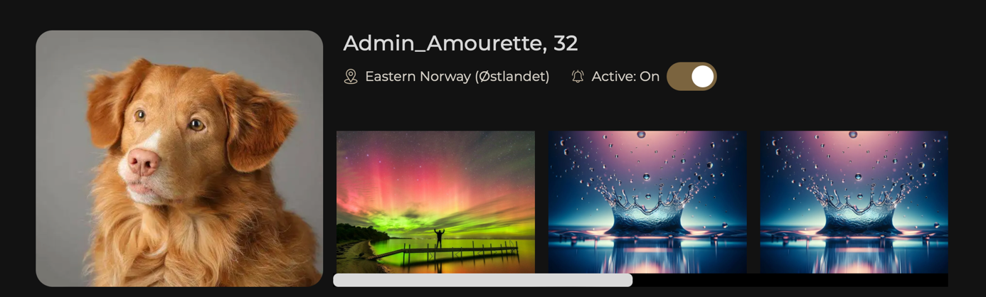Images in albums should be moveable between albums. ‘’Choose Album’’ so you can move it from Album 1 to Album 2 for example.   
  
  
  
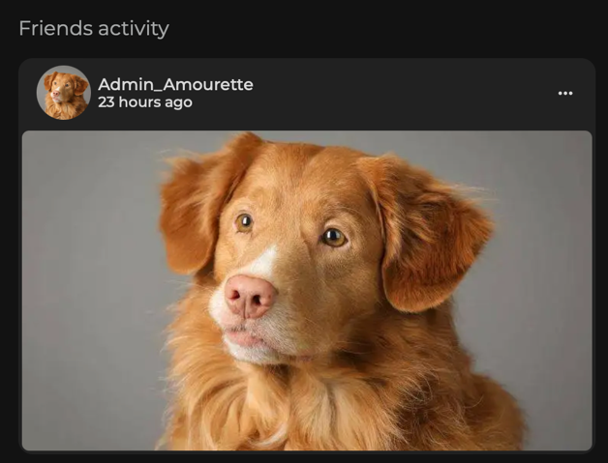  
Groups and Forums  
  
New activity in groups should update more frequently and be visible on the homepage, with the latest posts displayed at the top.  
  
Recent activity on profiles should display the last five comments, images, or posts to provide better insight into user activity.

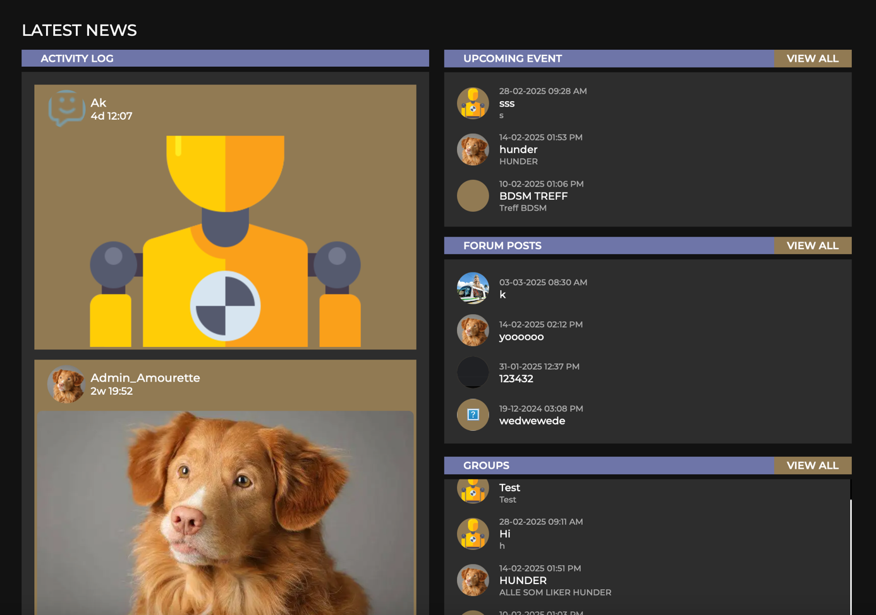  
Can we for a more refined and seamless design in line with the **Amourette** aesthetic, we can focus on the following adjustments:  
  
• **Rounded Corners**: Ensure all elements have smooth, rounded edges for a softer, more elegant look.  
• **Consistent UI Styling**: Match the typography, spacing, and button styles with the rest of the site to maintain visual harmony.  
• **Refined Transitions & Animations**: Add subtle hover effects and smooth transitions for a polished, high-end feel.  
• **Enhanced Image Navigation**: Improve the user experience by making image browsing fluid, with seamless animations when navigating left/right.  
• **Better Contrast & Visibility**: Ensure the UI elements stand out without feeling intrusive, using soft shadows and refined color tones.

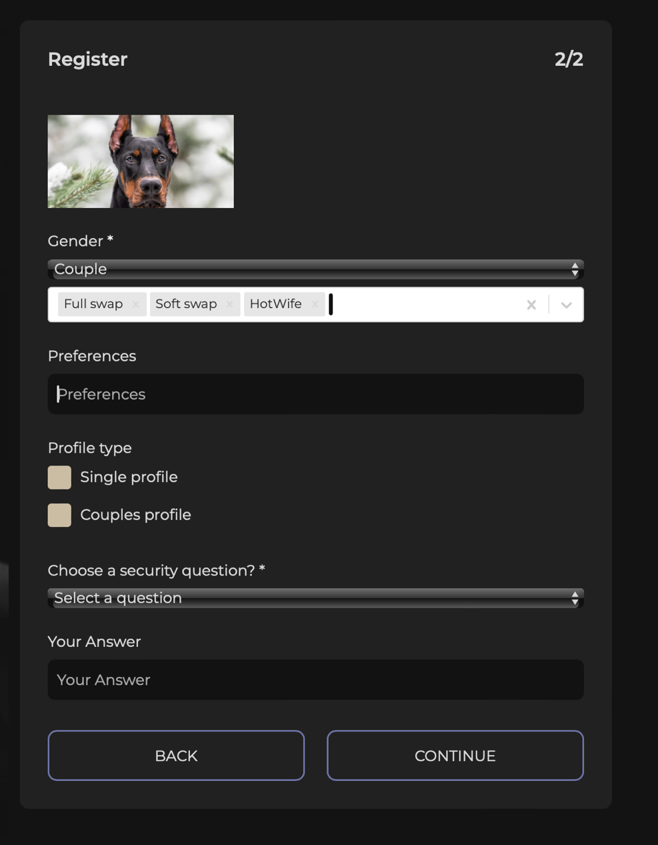  
Under “Preferences,” you should be able to select multiple options. These will also be displayed on your profile.

https://www.figma.com/design/DA82oLrMEXiJM4CvEIzNEM/Amourette?node-id=0-1&p=f&t=mNWP3M2i8VLfZGoh-0